**Bring files from staging area to working directory**

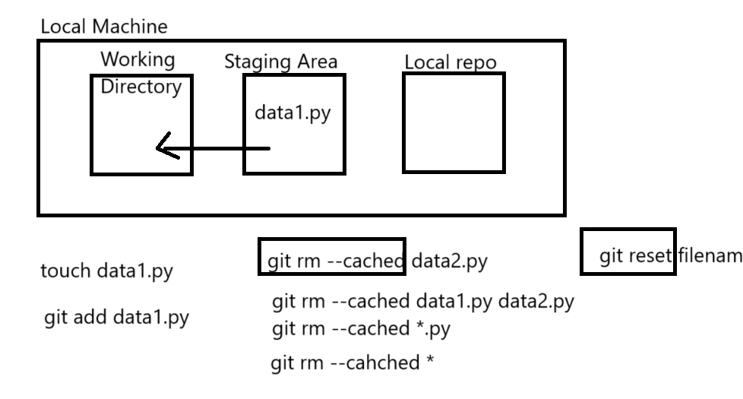

**Git Reset**

* It is used toggle between multiple versions of git and access whichever version we want.
* Reset can be done in 3 ways
  + Hard reset
  + Soft reset
  + Mixed reset

**Hard Reset**

* In hard reset HEAD simply points to an older commit and we can see the data as present at the time of that older commit
* It will delete data from working directory.
* Syntax:

git reset --hard commit_id

**Soft Reset**

* Soft reset will move the head to an older commit.
* Files will be present in the staging area.
* Syntax:

git reset --soft commitid

**Mixed Reset**

* Mixed reset moves the head to an older commit.
* The files will be present in the untracked/modified section

git reset --mixed commitid

**Work with git tags**

* Git tags are aliases for commit ids.
* Tags are always created against specific commit ids
* lists all available tags

git tag

* git show v1.2
  + shows which commit id tagged, who committed & what is committed
* git tag --a v1.2 -m "any message"
  + by default git tags the recent commit id / last commit id
* git tag --a v1.3 <commit id> -m "any message"
  + tags a specific commit id provided

**Branching in Git**

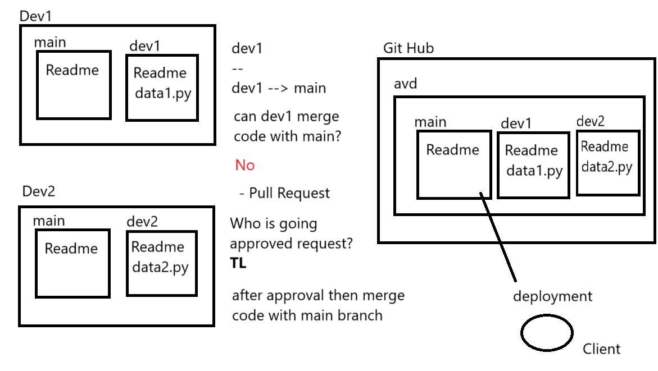

* Both Dev1 and Dev2 have their own local main branches and a dev1 and dev2 branch respectively.
* Dev1 has made changes data1.py in their dev1 branch.
* Dev2 has made changes data2.py in their dev2 branch.
* Dev1 wants to merge their changes from the dev1 branch into the main branch.
* merge is not allowed. This could be due to various reasons, such as:
* Conflicting Changes: Both Dev1 and Dev2 might have made changes to the same files, leading to merge conflicts.
* Unstable Code: The dev1 branch might not be stable enough to merge into the main branch.
* Dev1 creates a pull request to merge their dev1 branch into the main branch.
* A team lead (TL) is responsible for reviewing and approving the pull request.
* After the merge, the updated code from the main branch is deployed to the client.